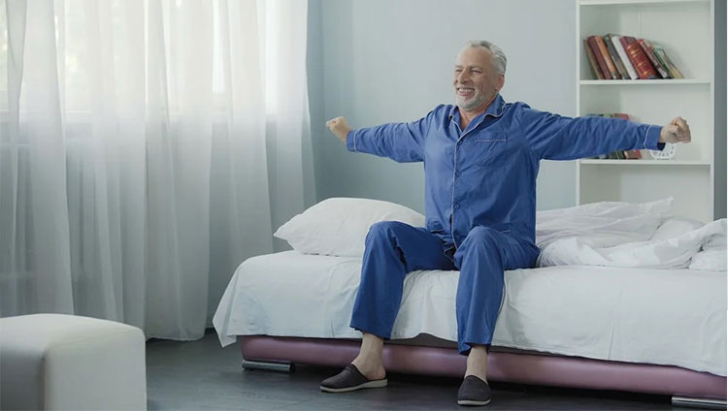

**Morning Aches: Understanding and Alleviating Back Pain After Sleep**

**Introduction:**

Waking up with back pain can set the tone for a challenging day ahead. Many individuals experience this discomfort, wondering why their restful night's sleep leads to morning aches. In this blog, we will delve into the causes of back pain after sleep and provide practical tips to understand, prevent, and alleviate this common issue.

**Understanding the Culprits:**

1. Sleeping Posture Matters:

The way you position your body during sleep can significantly impact your spine's alignment. Incorrect sleeping postures, such as sleeping on your stomach or using the wrong pillow, can contribute to back pain. Optimal sleeping positions include sleeping on your back with a supportive pillow or on your side with a pillow between your knees.

1. Mattress Selection:

The quality and type of mattress you sleep on play a crucial role in back health. An old, worn-out mattress or one that doesn't provide adequate support can lead to morning aches. Consider investing in a mattress that aligns with your preferred sleeping position and provides the necessary support for your spine.

**Preventing Morning Back Pain:**

1. Maintain Proper Sleep Hygiene:

Develop healthy sleep habits by establishing a consistent sleep schedule and creating a comfortable sleep environment. Limit screen time before bed, and ensure your bedroom is dark and quiet to promote restful sleep.

1. Strengthen Your Core:

A strong core provides support to your spine. Incorporate core-strengthening exercises into your fitness routine, such as planks, bridges, and pelvic tilts, to help stabilize your back and reduce the risk of morning pain.

**Alleviating Back Pain:**

1. Gentle Morning Stretches:

Incorporate gentle stretching into your morning routine to awaken and loosen tight muscles. Target areas like the lower back, hamstrings, and hip flexors to promote flexibility and reduce stiffness.

1. Heat Therapy:

Applying heat to the affected area can help relax tense muscles and improve blood circulation. Consider using a heating pad or taking a warm shower to ease morning back pain.

**When to Seek Professional Help:**

If morning back pain persists or worsens despite adopting preventive measures, it's essential to consult with an orthopedic professional. They can assess your individual situation, provide personalized recommendations, and rule out any underlying medical conditions contributing to your discomfort.

**Conclusion:**

Understanding and alleviating back pain after sleep involves a combination of lifestyle adjustments, preventive measures, and targeted interventions. By paying attention to your sleeping habits, investing in a supportive mattress, and incorporating simple yet effective exercises, you can wake up feeling refreshed and free from morning aches. If back pain persists, don't hesitate to seek guidance from an orthopedic expert to ensure a pain-free and healthy start to your day.

**Image Description:**

A serene bedroom setting with soft, natural light, showcasing a neatly made bed with supportive pillows. A person is seen in a comfortable sleeping position, perhaps on their back with proper spinal alignment. Alternatively, you could depict someone engaging in gentle morning stretches on the bed, emphasizing the importance of waking up and caring for the back.

This image aims to create a calming and positive visual association with the blog's content, reinforcing the idea of a restful sleep environment and healthy morning habits.

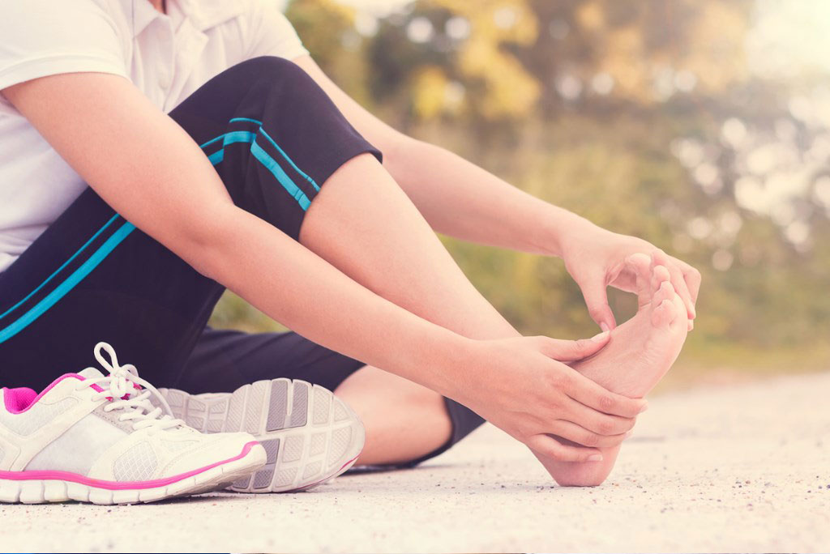

**Happy Feet: Preventing and Treating Pain After Long Walks**

**Introduction:**

Our feet are the unsung heroes of our daily lives, carrying us through countless steps and journeys. However, after a long walk, it's not uncommon to experience foot pain and discomfort. In this blog, we'll explore the reasons behind post-walk foot pain and provide practical tips on preventing and treating it, ensuring your feet stay happy and healthy.

**Understanding Post-Walk Foot Pain:**

1. Footwear Woes:

Ill-fitting shoes or those lacking proper support can lead to various foot issues, including pain, blisters, and calluses. Investing in comfortable, supportive footwear that suits your foot shape and the nature of your walk is crucial.

1. Overuse and Strain:

Walking long distances or standing for extended periods can strain the muscles and ligaments in your feet, leading to fatigue and pain. It's essential to gradually increase the intensity of your walks and listen to your body's signals to avoid overuse injuries.

**Preventing Foot Pain During and After Walks:**

1. Choose the Right Shoes:

Prioritize comfort and support when selecting walking shoes. Consider factors such as arch support, cushioning, and proper sizing to ensure your feet are well-protected during your walks.

1. Gradual Conditioning:

If you're planning to increase your walking distance, do so gradually. Allow your feet and muscles time to adapt to longer walks to reduce the risk of overuse injuries.

**Treating Post-Walk Foot Pain:**

1. Rest and Elevation:

After a long walk, give your feet some well-deserved rest. Elevate your feet to reduce swelling and promote blood circulation, helping alleviate pain and discomfort.

1. Ice and Massage:

Applying ice to sore areas and massaging your feet can help reduce inflammation and soothe tired muscles. Consider rolling your feet over a frozen water bottle for a simple and effective massage.

**Photo Suggestion:**

For this blog, consider using an image that captures the essence of happy and healthy feet. Here's a suggestion:

Image Description:

A pair of well-worn, comfortable walking shoes placed on a welcoming doormat, surrounded by greenery or a scenic walking trail. This image symbolizes the beginning and end of a satisfying walk, emphasizing the importance of the right footwear for happy and pain-free feet.

This photo choice aims to resonate with readers, encouraging them to make thoughtful choices about their walking footwear to prevent and alleviate foot pain.



**The Pillow Predicament: Solving Neck Pain Issues**

**Introduction:**

Waking up with a stiff neck can be an unwelcome start to the day, and the culprit may be right under your head – your pillow. In this blog, we'll unravel the mysteries of the pillow predicament, exploring how the choice of pillow can impact neck health and providing valuable insights to help you bid farewell to morning neck pain.

**The Neck-Pillow Connection:**

1. Pillow Height and Support:

The height and support of your pillow play a crucial role in maintaining proper neck alignment. A pillow that is too high or too low can strain the neck muscles and contribute to discomfort. Finding the right balance is key.

1. Sleep Position Matters:

Different sleep positions require varying levels of support. Side sleepers may benefit from a thicker pillow to keep the spine aligned, while back sleepers might find a medium-thickness pillow more suitable. Stomach sleepers should opt for a thinner pillow to prevent excessive neck strain.

**Choosing the Ideal Pillow:**

1. Material Matters:

Pillows come in various materials, including memory foam, feather, and latex. Each material has its unique benefits. Memory foam conforms to the shape of your neck, while feather pillows provide a soft, adjustable feel. Consider your personal preferences and any allergies when selecting the right material.

1. Replacing Old Pillows:

Pillows have a lifespan, and using an old, worn-out pillow can contribute to neck pain. Replace your pillows regularly, especially if they show signs of flattening or losing their shape.

**Tips for a Neck-Friendly Sleep Environment:**

1. Bed and Mattress Alignment:

Ensure that your mattress is in good condition and provides adequate support. The combination of a supportive mattress and the right pillow can significantly impact your sleep quality and neck health.

1. Temperature and Pillow Covers:

Maintain a comfortable sleep environment by using breathable pillow covers and adjusting the room temperature. Excessive heat or cold can affect the pliability of your pillow and, subsequently, your neck support.

**Photo Suggestion:**

For this blog, consider using an image that visually conveys the importance of a well-chosen pillow. Here's a suggestion:

Image Description:

A well-made bed with a selection of pillows, each representing a different type (memory foam, feather, latex). A person is shown adjusting a pillow to find the optimal height and support, emphasizing the importance of a personalized and comfortable sleep setup.

This photo choice aims to resonate with readers, encouraging them to assess and choose the right pillow for their unique sleep needs, ultimately preventing neck pain and ensuring a restful night's sleep.



**Knee Care 101: Avoiding Pain from Stairs and Incorrect Movements**

**Introduction:**

Our knees play a fundamental role in our daily movements, and knee pain can significantly impact our ability to navigate stairs and perform routine activities. In this blog, we'll delve into Knee Care 101, exploring the causes of knee pain related to stairs and incorrect movements, and providing practical tips to keep your knees healthy and pain-free.

**Understanding the Causes:**

1. Improper Stair Use:

Ascending or descending stairs improperly can place undue stress on the knees. Whether it's putting too much weight on one leg or taking steps too quickly, these habits can contribute to knee pain over time.

1. Incorrect Movements:

Everyday movements, such as sitting down or standing up incorrectly, can strain the knee joints. Poor posture, improper weight distribution, and sudden movements can all play a role in causing knee discomfort.

**Preventing Knee Pain:**

1. Proper Stair Technique:

When using stairs, focus on distributing your weight evenly between both legs. Use the handrail for support and take one step at a time. Avoid rushing or taking overly large steps, as this can strain the knee joints.

1. Mindful Sitting and Standing:

Be conscious of your movements when sitting down or standing up. Use your leg muscles to support the movement, keeping the knee in a stable and aligned position. Avoid sudden or jerky movements that can stress the knee joints.

**Strengthening Exercises for Knee Health:**

1. Quad Strengthening:

Incorporate exercises that strengthen the quadriceps, such as leg lifts and squats. Strong quadriceps provide crucial support to the knee joint.

1. Hamstring Stretches:

Keep the hamstrings flexible through regular stretching. This helps maintain balance around the knee and reduces the risk of injury.

**Photo Suggestion:**

For this blog, consider using an image that illustrates proper stair use and knee-friendly movements. Here's a suggestion:

Image Description:

A person is shown using proper technique while ascending or descending stairs, emphasizing even weight distribution and the use of a handrail for support. Another image can depict someone practicing mindful sitting and standing, highlighting the importance of controlled movements to protect the knees.

These images aim to visually reinforce the blog's message on adopting proper techniques to prevent knee pain from stairs and incorrect movements, promoting knee care and overall joint health.



**On the Road Again: Preventing Hip Pain During Long Drives**

**Introduction:**

Long drives can be both liberating and exhausting, and for many, they come with an unwelcome companion—hip pain. In this blog, we'll explore the common causes of hip pain during extended periods of driving and provide practical tips to keep your hips happy and pain-free during your road trips.

**Understanding the Causes:**

1. Prolonged Sitting:

Sitting for extended hours without proper breaks can lead to stiffness and discomfort in the hip joints. Blood circulation may be compromised, contributing to hip pain.

1. Poor Driving Posture:

Incorrect driving posture, such as slouching or sitting too close to the steering wheel, can strain the hips. Adjusting the seat and steering wheel to a comfortable and ergonomic position is essential.

**Preventing Hip Pain During Long Drives:**

1. Regular Breaks and Stretching:

Schedule breaks during long drives to stretch and move around. Simple hip stretches, such as hip flexor stretches and leg swings, can help alleviate tension and improve circulation.

1. Ergonomic Seat Adjustments:

Take the time to adjust your car seat properly. Ensure your hips are at the same level as or slightly above your knees, and the backrest provides adequate support. Use cushions or lumbar rolls if needed.

**Comfortable Driving Habits:**

1. Maintain a Relaxing Grip:

Hold the steering wheel with a relaxed grip to prevent tension in the hips and upper body. Avoid gripping the wheel too tightly, as this can contribute to discomfort.

1. Shift Positions Regularly:

Change your sitting position periodically. Shifting from a slightly reclined position to an upright one, or vice versa, can reduce the strain on specific areas of the hips.

**Photo Suggestion:**

For this blog, consider using an image that conveys the idea of comfortable driving posture and taking breaks during a road trip. Here's a suggestion:

Image Description:

A well-adjusted car seat with cushions and proper lumbar support, emphasizing ergonomic driving posture. Additionally, show an individual taking a break during a road trip, standing next to their car and performing simple hip stretches.

These images aim to visually reinforce the importance of comfortable driving habits and taking breaks to prevent hip pain during long drives. They encourage readers to adopt mindful practices for a more enjoyable and pain-free travel experience.



**Shoulder Struggles: Sorting Orthopedic from Hormonal Issues**

**Introduction:**

Shoulder pain and fatigue are common complaints that can arise from various causes. In some cases, the source may be orthopedic, while in others, hormonal factors may be at play. In this blog, we'll explore the nuances of shoulder struggles, helping readers understand how to distinguish between orthopedic and hormonal issues and guiding them toward the right solutions.

**Understanding Shoulder Pain:**

1. Orthopedic Causes:

Shoulder pain can stem from various orthopedic issues, including rotator cuff injuries, tendonitis, or joint instability. Understanding the specific nature of the pain and any accompanying symptoms is crucial in identifying orthopedic sources.

1. Hormonal Influences:

Hormonal changes, such as those related to the menstrual cycle, pregnancy, or menopause, can impact joint health. Fluctuations in estrogen levels may contribute to inflammation and increased vulnerability to shoulder pain.

**Differentiating Between Orthopedic and Hormonal Issues:**

1. Orthopedic Symptoms:

Orthopedic shoulder pain often comes with specific symptoms such as limited range of motion, localized tenderness, or a clicking sensation. Identifying these symptoms can help narrow down the potential orthopedic causes.

1. Hormonal Patterns:

Hormonal-related shoulder pain may exhibit patterns linked to the menstrual cycle or hormonal changes associated with pregnancy or menopause. Understanding the timing and consistency of the pain can provide clues to its hormonal origin.

**Seeking Professional Guidance:**

1. Orthopedic Consultation:

If shoulder pain is persistent, consult with an orthopedic specialist. They can conduct a thorough examination, imaging tests, and recommend appropriate treatments or physical therapy for orthopedic issues.

1. Hormonal Assessment:

For those suspecting hormonal influences, seeking guidance from a healthcare provider is essential. Hormonal assessments and discussions about reproductive health can help identify and address hormonal contributors to shoulder struggles.

**Photo Suggestion:**

For this blog, consider using an image that visually represents the duality of orthopedic and hormonal influences on shoulder health. Here's a suggestion:

Image Description:

A split-image showing a person engaging in orthopedic exercises or physical therapy for the shoulder on one side and another image depicting a woman consulting with a healthcare professional regarding hormonal issues on the other side. This visual metaphor represents the dual approach to addressing shoulder struggles.

These images aim to emphasize the need for a comprehensive understanding of shoulder pain, encouraging readers to consider both orthopedic and hormonal factors and seek appropriate professional guidance for accurate diagnosis and treatment.